Stock Portfolio Data Analysis

Task:

Given 3 CSV files containing dummy stock trade data. Overall objective is to compute portfolio returns and portfolio value (individual holdings + portfolio).

Steps, to help you, are as under.

To do:

1. Create a simple data structure to append and store the files.
2. Create a master list of holdings
3. Get stock split details, if available. If a stock has split 1:2, it means price has become half and quantity has doubled.
4. Transform input files to reflect split adjusted price and quantity. It needs to be done iteratively basis the split date. Adjust trading cashflow as adjusted price * adjusted quantity.
5. Get historical daily currency pairing for each date (USD, INR, SGD)
6. Compute transaction price in each currency
7. Get split adjusted historical prices / NAVs of the stocks / mutual funds through yahoo finance / amfi
8. Compute daily portfolio value across currencies. Portfolio value = Quantity * price, summed for all holdings
9. Compute XIRR for each holding
10. Represent through a simple UI

Bonus: through APIs, bring latest news of the holdings.

Tips:

1. Too many requests to yahoo finance may block the IP

Work Done Details:

1. The task from 1 to 9 are done in stock_analysis.ipynb file
2. Task 10, a streamlit application has been developed for the frontend and the details are in app.py file

Steps to run the project:

1. Download the repository (As the deployment wasn’t successful due to dependencies issue)
2. Install all the requirements listed in the file requirement.txt
   * pip install -r requirements.txt
3. Run the stock_analysis.ipynb, to download certain .csv files for further analysis
4. Run the app.py file using
   * streamlit run app.py

Insights from the UI:

* Portfolio Overview:

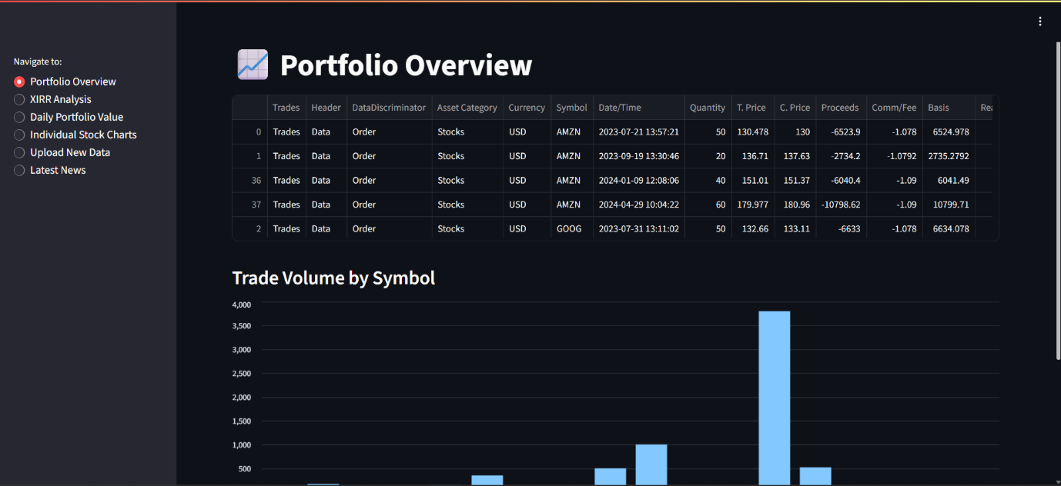

* XIRR by Stock:

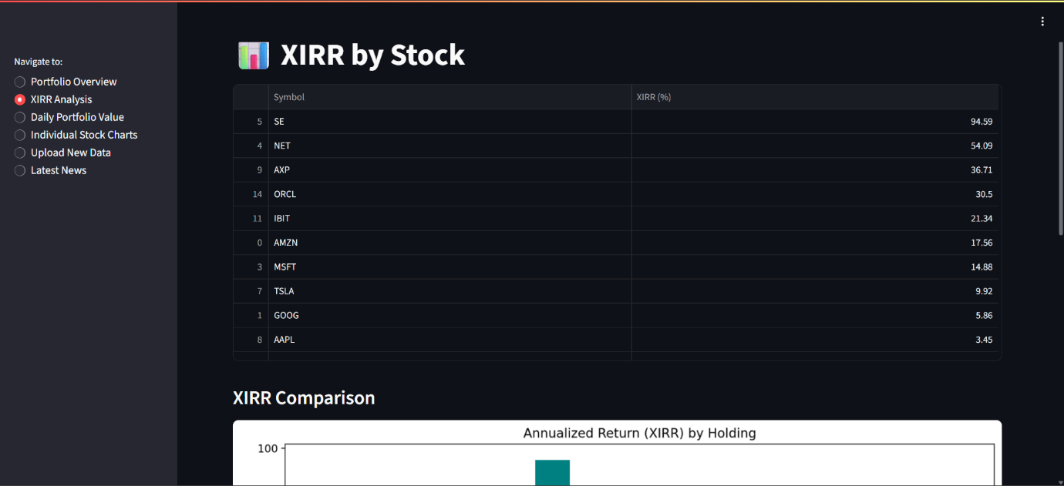

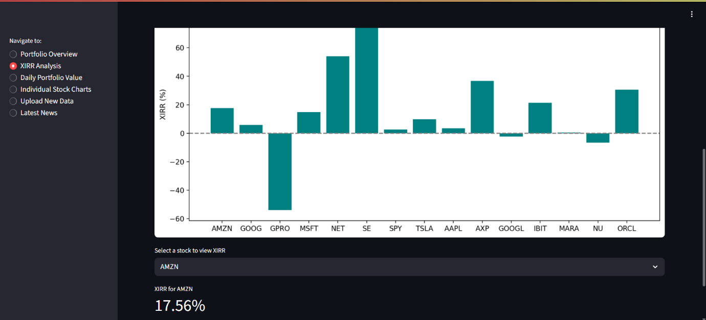

* Daily Portfolio Value:

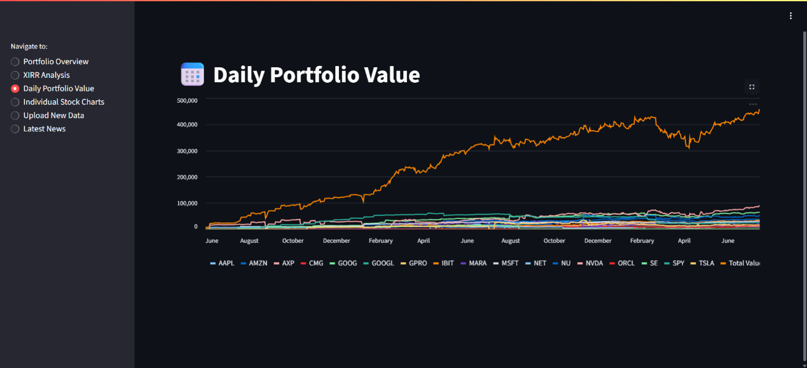

* Individual Stock Activity:

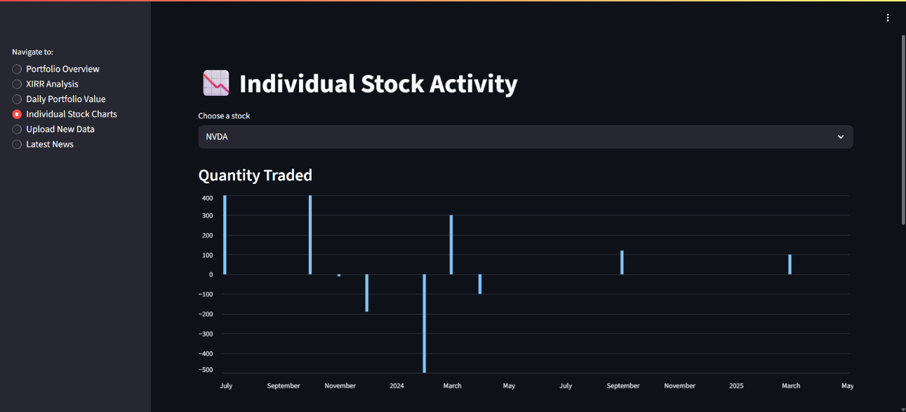

* Latest Stock Market News

